Alec Webb  
MATH446

**Project 3: Newton's Method Results**

**Equations Used:**

$$f\left(x\right)= 12x\sqrt{x}- \left(8+12π\right)x+\left(24\sqrt{x}- 16\right)\sin{\sqrt{x}}+ \left(3π^{2}+8π-24\right)\sqrt{x}- 2π^{2}+ 16=0$$

$$f^{'}\left(x\right)= 18\sqrt{x}+ \frac{-24+8π+3π^{2}}{2\sqrt{x}}+ \frac{12\sin{\sqrt{x}}}{\sqrt{x}}+ \frac{\left(24\sqrt{x}-16\right)\cos{\sqrt{x}}}{2\sqrt{x}}-12π-8$$

$$f^{''}\left(x\right)= -\frac{-24+8π+3π^{2}}{4x^{\frac{3}{2}}}- \frac{6\sin{\sqrt{x}}}{x^{\frac{3}{2}}}- \frac{(24\sqrt{x}-16)\cos{\sqrt{x}}}{4x^{\frac{3}{2}}}+\frac{9}{\sqrt{x}}- \frac{(24\sqrt{x}-16)\sin{\sqrt{x}}}{4x}+\frac{12\cos{\sqrt{x}}}{x}$$

**1.)**

|  |  |  |
| --- | --- | --- |
| **Initial Guess** | **Root** | **Convergence Type** |
| 0.3 | 0.444444444444450 | Quadratic* |
| 2.2 | 2.466440855251409 | Linear** |

**Problem with interval including x = 0.7:**  
 The problem with the values around this x is due to the line that is tangent is pointing into the negative numbers due to the inclusion of square roots in our original equation. Or pointing to a new starting point which cannot be resolved.

**2.)**

**Quadratic Convergence: $\frac{4}{9}$**

|  |  |
| --- | --- |
| **Newton Iteration** | **Theoretical Value** |
| -3.830878826669657 | M = 0.912315780795651 |

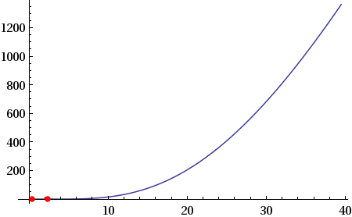  
**Encountered a discrepancy:** f'(0.4444444444444444) is not equal to zero, so should be quadratic. However the ratio output from the MATLAB session is around -3.8. Is this due to the nature of the curve at 0.4444... (repeating) while being relatively flat?  
  
*The errors roughly double with each step

**3.)**

**Linear Convergence: $\frac{π^{2}}{4}$**

|  |  |
| --- | --- |
| **Newton Iteration** | **Deduced Multiplicity** |
| 0.746189018693704 | m=4 (approx 3/4) |

**Rationale:** f'($\frac{π^{2}}{4}$) = 0; Indicative of linear convergence.  
  
**The errors do not double with each step